### **DECLARATION**

I hereby declare that the project work entitled **“Online Voting System”**, submitted as part of the evaluation for the subject **Database Management System** in the **4th semester** of the **Bachelor of Technology in Computer Engineering**, is an authentic record of my own work, carried out under the supervision of **Prof. .**

This project report has not been submitted, either wholly or in part, for any course or degree at this or any other institute/university.

**Anurag Bhatt**        

### **SUPERVISOR CERTIFICATE**

To the best of my knowledge, the report titled **“Online Voting System”** is based on original work completed by the students as part of their 4th semester curriculum for the subject **Database Management System**. This work has not been submitted elsewhere for any course or degree, in part or full, as per the student’s declaration.

**Place:** New Delhi  
**Date:**

**Prof.**   
(Supervisor)

**Online Voting System**

***DBMS (CS 210n)***



# CONTENTS

* **Synopsis**
* Introduction
* Technical Requirements
* Schemas
* Entity-Relationship (ER) Diagram
* Transforming ER Diagram into Tables
* SQL Queries & Implementation
* Features of the Online Voting System
* Conclusions
* References

**Synopsis**

The Online Voting System's primary objective is to offer straightforward, safe, and easily accessible platform for digital election administration. By eliminating the need for voters to physically visit polling places and enabling registered users to cast their ballots online from any location, this project seeks to streamline the voting process. Students, working people, and anybody else who is unable to be physically present during elections will find it especially helpful.

Users can register using this system by providing their voter and personal information, which is safely kept in a database. After logging in, they can vote for one candidate, view their dashboard, and see a list of candidates along with the names and symbols of their parties. To avoid duplicate voting, their status is changed to "Voted" after they have cast their ballot. Additionally, there’s also an admin panel where candidates can be added or managed, and all data is protected with login authentication to ensure privacy and security.

Introduction

**Proposal for the Problem:**  
  
India’s current voting system faces major issues like long queues, delays, and limited accessibility. Students, working professionals, and people living away from home often miss voting due to the rigid offline process. Manual vote counting is time-consuming and error-prone, and issues like unauthorized voting and data inconsistency affect trust and transparency.  
  
Project Resolution:  
  
I propose an **Online Voting System**—a secure and user-friendly digital platform that enables registered users to vote remotely. The system features voter registration, a separate admin panel, and a voter dashboard. Each user is allowed to vote only once, with their status auto-updated post-voting.

#### **Key Features:**

**1) Secure Registration & Login:** Users can register with personal details and a protected password. All data is stored in the database for future access.

**2) One-Person, One-Vote System:** Once a vote is cast, it cannot be changed or repeated. The system updates the status from “Not Voted” to “Voted.”

**3) Clear Voting Dashboard:** The dashboard displays voter information alongside a list of candidates, including party names and symbols.

**4) Admin Control Panel:** A separate login for the admin allows adding candidates, uploading photos and symbols, and viewing overall voting stats.

**Technical Requirements**

**PhpMyAdmin:**

PhpMyAdmin is a user-friendly, web-based tool used to manage MySQL databases. It provides a clean graphical interface, which makes it easier to create, edit, and manage databases without needing to write complex commands. Since it runs through a web browser, you can access it from any computer that’s connected to the server.

It allows you to manually create databases and tables, run SQL queries, and view or modify data easily. Whether you're a beginner or someone familiar with databases, phpMyAdmin makes the process smoother and more visual.

#### **Key Features of phpMyAdmin:**

1. You can create, edit, browse, or delete databases, tables, columns, and indexes easily.
2. It supports foreign keys and Inno DB tables, which help maintain data consistency.
3. You can run stored procedures and queries and view multiple result sets at once.
4. It keeps track of changes made to the database structure, including views and tables.
5. You can generate a PDF layout of your database structure for better visualization.
6. Stored data (like images or files) can be transformed and shown in different formats.
7. It also allows you to back up your entire database in various file formats for safety.

**XAMPP:**

**XAMPP** is a free and open-source software package that provides a local development environment for building and testing web applications. The name **XAMPP** stands for:

* **X** – Cross-Platform (it works on Windows, macOS, and Linux)
* **A** – Apache (the web server)
* **M** – MariaDB (the database system, a fork of MySQL)
* **P** – PHP (a server-side scripting language)
* **P** – Perl (another scripting language used in web development)

XAMPP bundles all these tools into one easy-to-install package. It allows developers to simulate a real server environment on their own computer. This means you can develop, test, and debug your website or application locally—without needing an internet connection or a live server.

XAMPP includes:

* **Apache**, which acts as the web server.
* **MariaDB**, which stores and manages your project’s database.
* **PHP**, which powers the server-side logic.
* **Perl**, which can also be used for backend scripting (though it's less common today).

With XAMPP, you can run your project as if it's live on the internet, helping you catch bugs and test features before making it public. It’s especially helpful for students, beginner developers, or anyone working on PHP-based or database-driven websites.

**MySQL:**

MySQL is a well-known relational database management system (RDBMS) that organizes and manages data using SQL (Structured Query Language). It is frequently used in web development to efficiently and systematically store and retrieve data.

MySQL is most frequently used as a web database, which helps websites store user data, login credentials, content, and more. However, it can also handle large-scale tasks like data warehousing, e-commerce platforms, and log management. It is frequently utilized in dynamic websites and applications because it is dependable, quick, and compatible with backend languages like PHP.  
  
**HTML CSS:**

The Hypertext Markup Language (HTML) is the standard markup language for documents designed to be displayed in a web browser. It can be assisted by technologies such as Cascading Style Sheets (CSS) and scripting languages such as JavaScript.

SCHEMAS

Voter Registration:

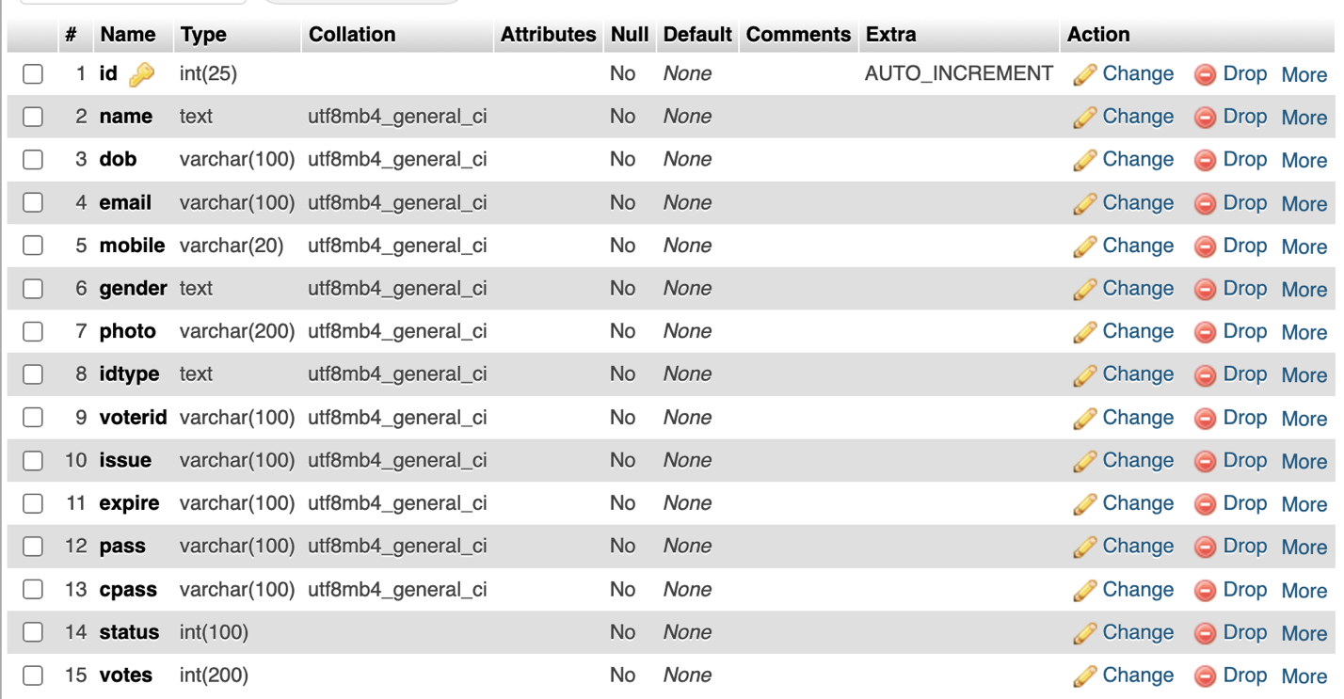

Admin Login:

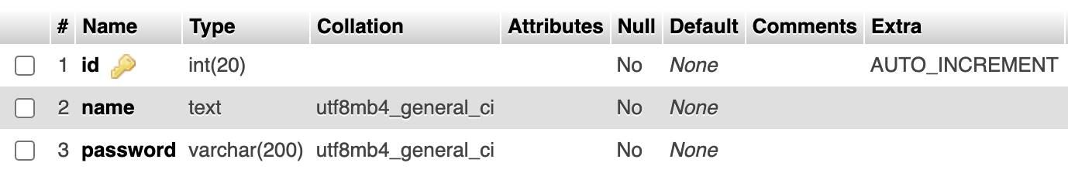

Add Candidate:

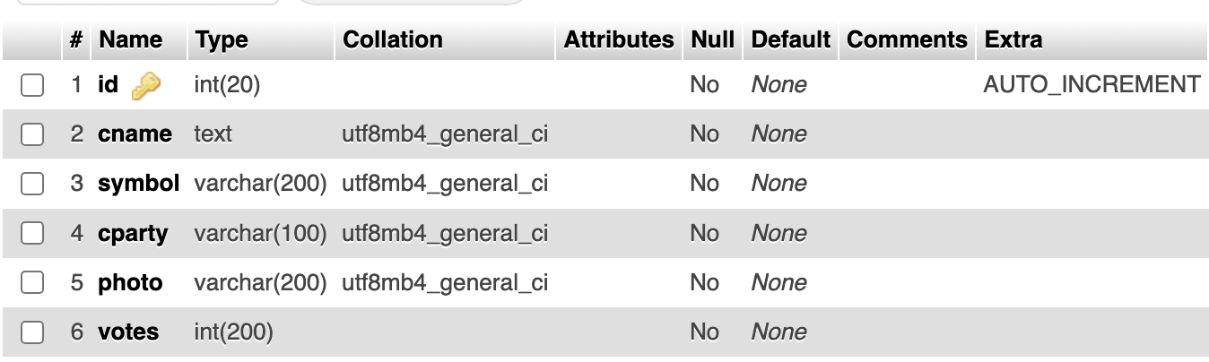

Entity-Relationship (ER) Diagram

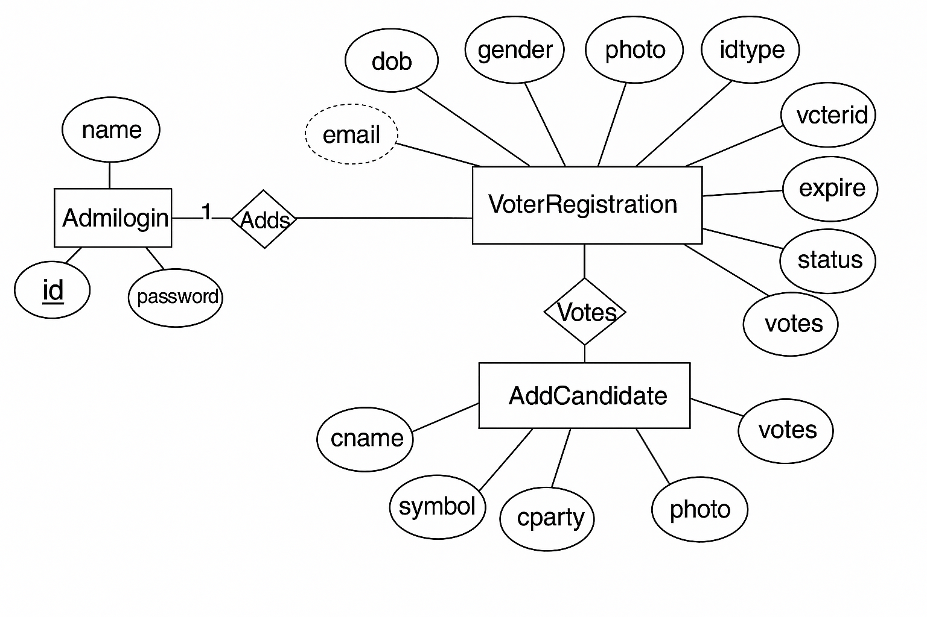

TRANSFORMING ER DIAGRAM INTO TABLES

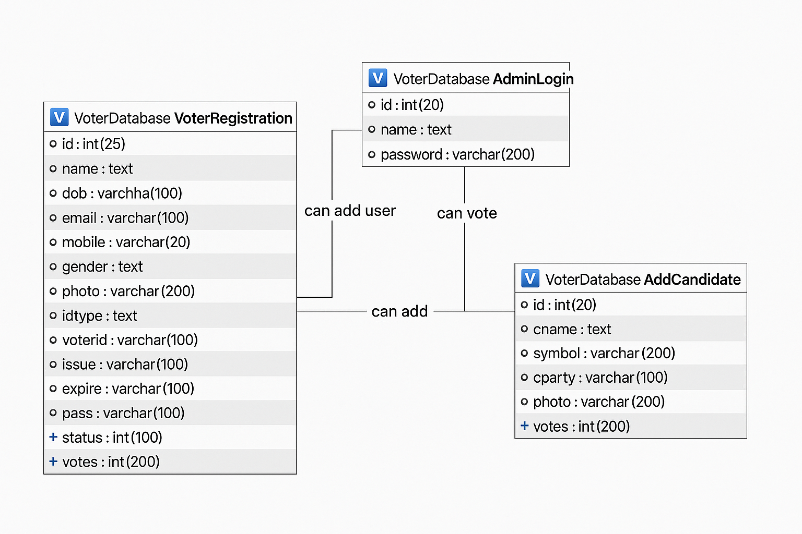 SQL Queries & Implementation

**Table 1: Add Candidate:**

CREATE TABLE `AddCandidate` (

`id` int(20) NOT NULL,

`cname` text NOT NULL,

`symbol` varchar(200) NOT NULL,

`cparty` varchar(100) NOT NULL,

`photo` varchar(200) NOT NULL,

`votes` int(200) NOT NULL);

ALTER TABLE `AddCandidate`

ADD PRIMARY KEY (`id`);

-

ALTER TABLE `AddCandidate`

MODIFY `id` int(20) NOT NULL AUTO_INCREMENT, AUTO_INCREMENT=18;

**Table 2:Admin Login:**

CREATE TABLE `AdminLogin` (

`id` int(20) NOT NULL,

`name` text NOT NULL,

`password` varchar(200) NOT NULL);

ALTER TABLE `AdminLogin`

ADD PRIMARY KEY (`id`);

ALTER TABLE `AdminLogin`

MODIFY `id` int(20) NOT NULL AUTO_INCREMENT, AUTO_INCREMENT=3;

**Table 3: Voter Registration:**  
  
CREATE TABLE `VoterRegistration` (

`id` int(25) NOT NULL,

`name` text NOT NULL,

`dob` varchar(100) NOT NULL,

`email` varchar(100) NOT NULL,

`mobile` varchar(20) NOT NULL,

`gender` text NOT NULL,

`photo` varchar(200) NOT NULL,

`idtype` text NOT NULL,

`voterid` varchar(100) NOT NULL,

`issue` varchar(100) NOT NULL,

`expire` varchar(100) NOT NULL,

`pass` varchar(100) NOT NULL,

`cpass` varchar(100) NOT NULL,

`status` int(100) NOT NULL,

`votes` int(200) NOT NULL);

ALTER TABLE `VoterRegistration`

ADD PRIMARY KEY (`id`);

ALTER TABLE `VoterRegistration`

MODIFY `id` int(25) NOT NULL AUTO_INCREMENT, AUTO_INCREMENT=12;

Features of the Online Voting System

**Registration of New Voter:**

New voters need to fill the registration form with correct and credible information.

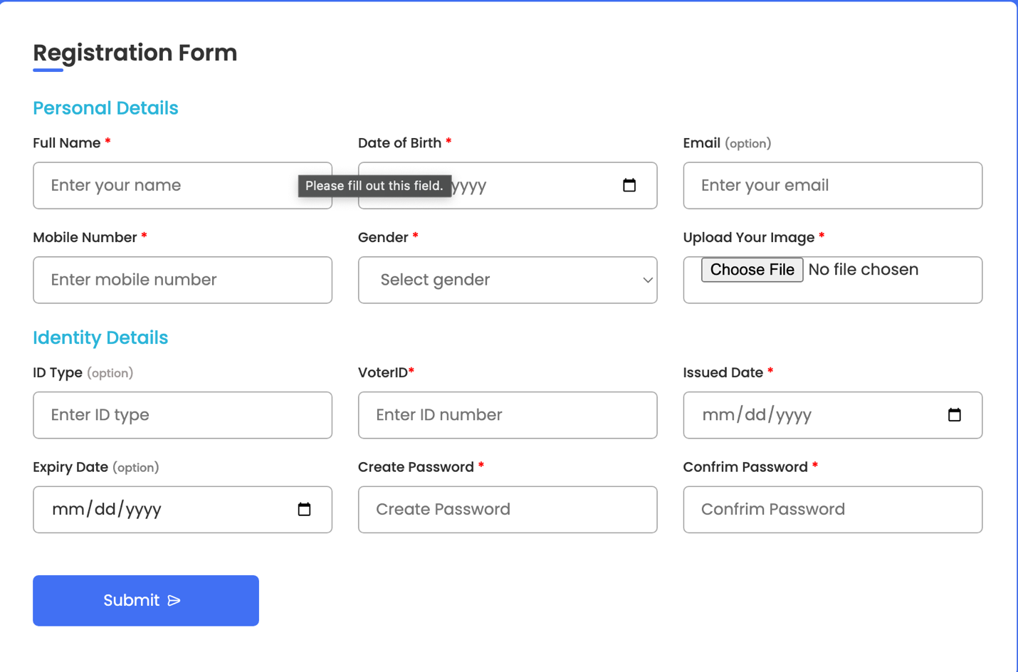

**Voter login:**

Once you register ,you will be redirected here. Here the voter can Login by entering voterID , mobile no, and Password.

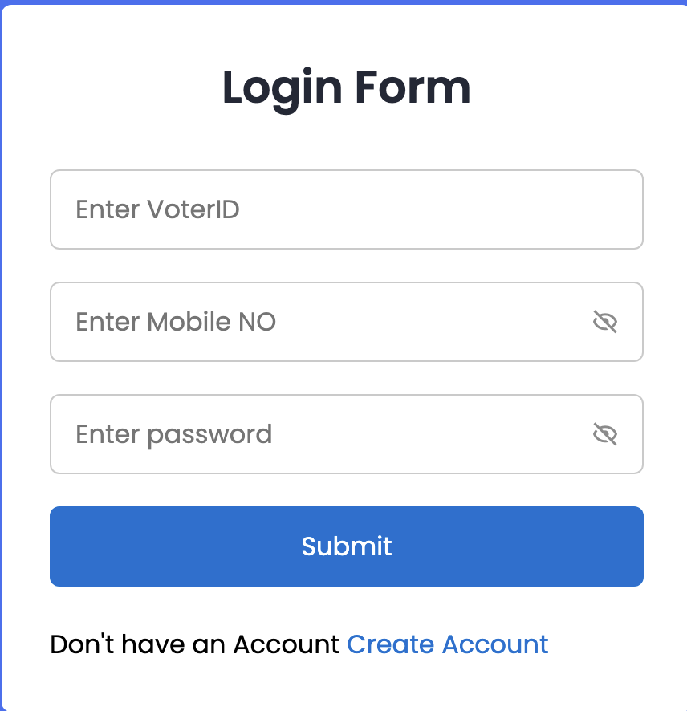

**Homepage:**

After you login, you will be redirected to the homepage .Here information about candidate and the voter will be displayed. The voter can vote the candidate. Also there is Admin panel for the registration of the candidate.

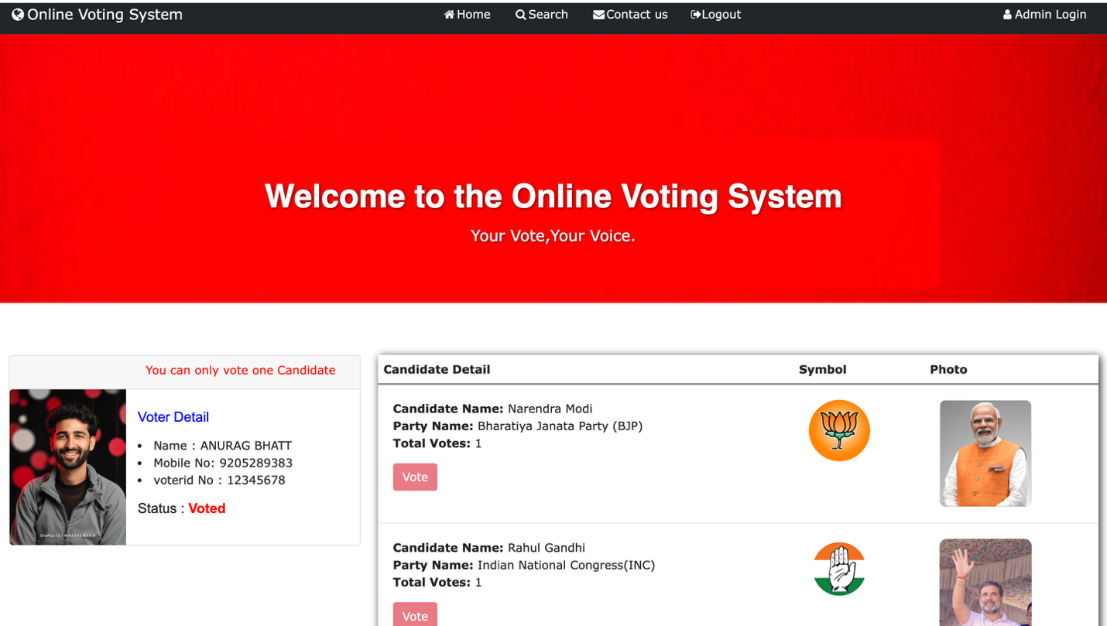



**Admin Panel:**

Here admin needs to enter name and password to go the admin dashboard where candidate can register.

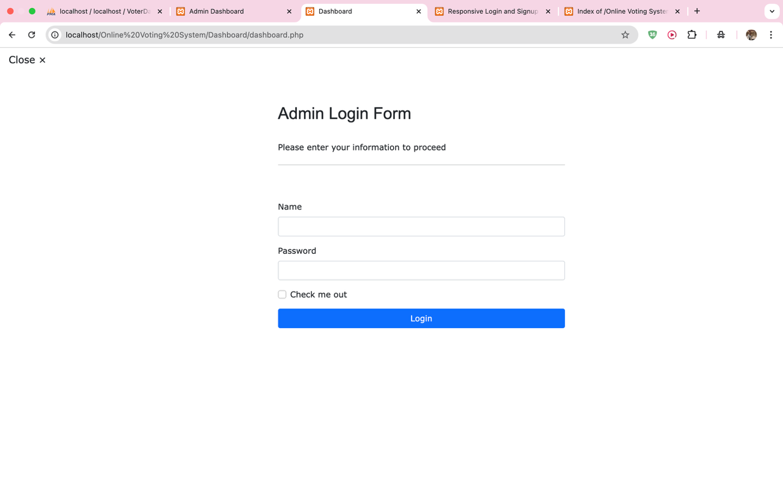

**Homepage After filling Admin login form:**

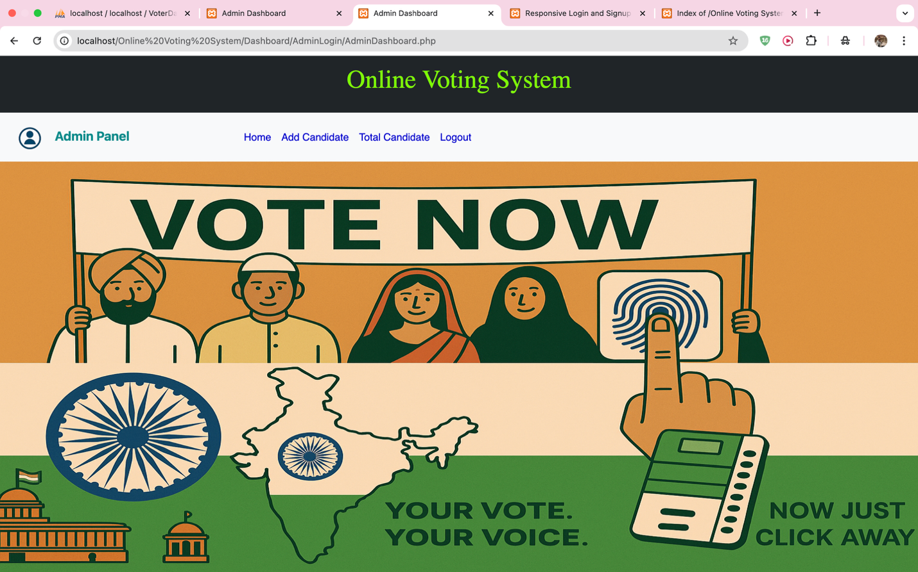

**Candidate Registration:**

Candidates willing to participate in the election can fill this form and officially register for the election.

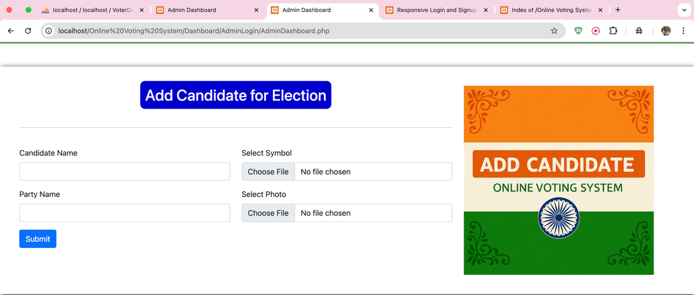

**List of candidates:**

Total list of candidates will be visible in the Admin Panel itself

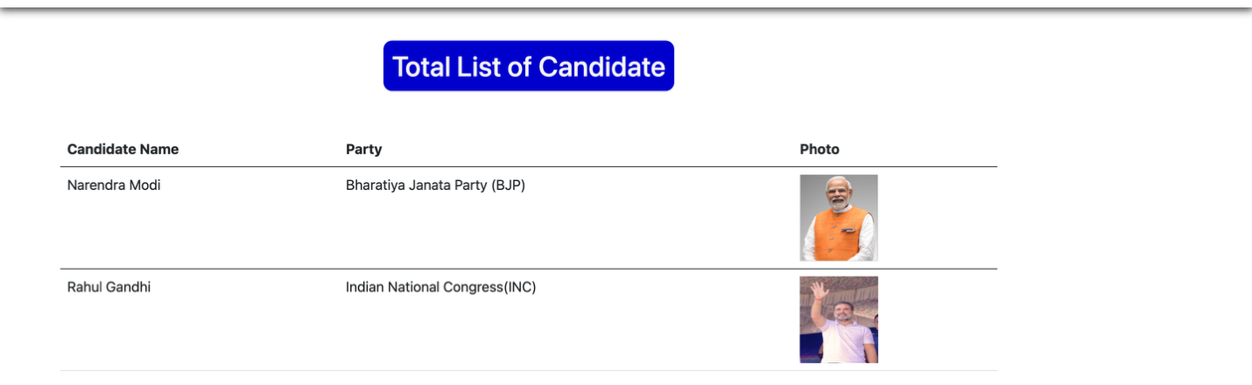

**How to Vote:**

You can only vote once to any one candidate. Once you have voted ,the vote button will be disabled, just like in the photo.

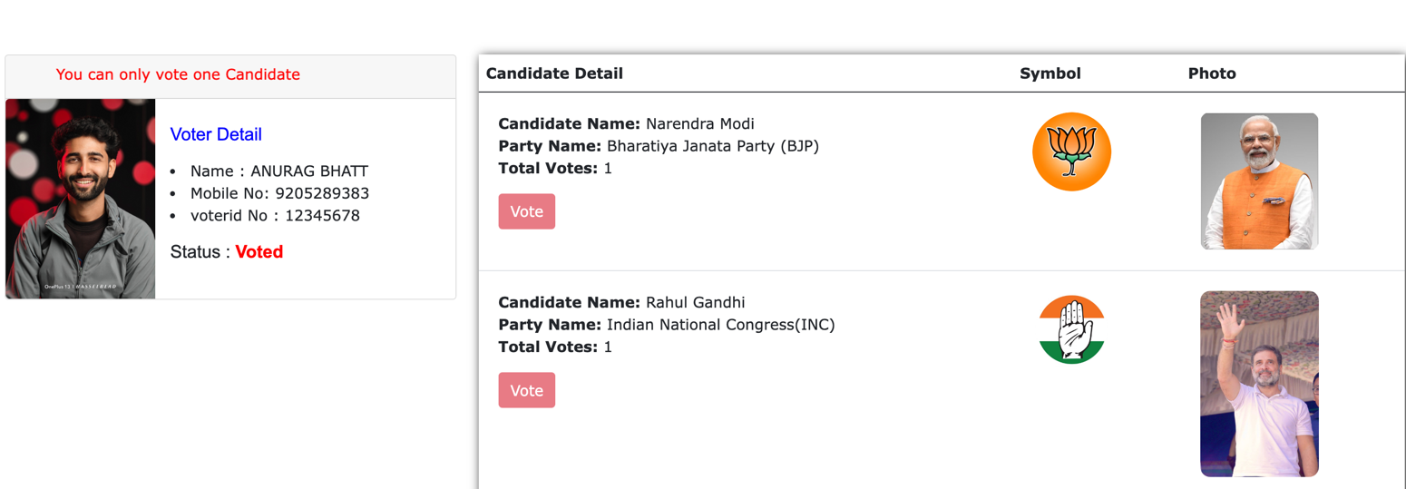 Conclusion



Voters can now cast their ballots online from any location thanks to the Online Voting System, a safe and easy-to-use web application. Numerous drawbacks of conventional voting procedures are addressed by the system, including lengthy lines, manual vote counting, and the inconvenience experienced by residents who live far from their registered addresses.

PHP, MySQL, and XAMPP were used in the construction of this project, providing a solid framework for front-end and back-end functions. Because of its popularity, ease of use, and dependability, MySQL was chosen as the database system. Important data, including voting records, candidate information, and user details, are efficiently stored and retrieved by it. Each user can only vote once, according to the system, and their dashboard automatically updates the voting status to avoid multiple votes.

In addition to applying the theoretical knowledge I've learned in my coursework, working on this project alone allowed me to comprehend the practical steps involved in designing, developing, and testing a working web application. I developed as a developer and improved my problem-solving skills by overseeing every aspect of the project, from the database design and backend logic to the user interface.

During this trip, I acquired hands-on experience in:

1) Structuring and implementing a full-stack web application

2) Applying proper planning and organized methodology

3) Troubleshooting independently and learning through challenges

**References**

**1)** [**https://getbootstrap.com**](https://getbootstrap.com)

**2)** [**https://developer.wordpress.org/advanced-administration/upgrade/phpmyadmin/**](https://developer.wordpress.org/advanced-administration/upgrade/phpmyadmin/)

**3)** [**https://developer.mozilla.org/en-US/docs/Web/CSS**](https://developer.mozilla.org/en-US/docs/Web/CSS)